**RETROICOR tutorial**

Step 1: Recording physiological measures using Brainamp

* The setup above consists of: a Brainamp ExG MR amplifier, an ExG AUX set, a pulse sensor coupler, and a respiration belt/coupler. All this equipment is placed inside the scanner room with the participant. The Brainamp ExG is connected using an optical cable to the PC running Brainvision recorder in the console room.
* In Brainvision recorder, use a workspace that includes heart rate and respiration (eg ‘workspace_erno.rwksp’ in the ‘BRAINAMP_data’ folder). The example dataset used 5000 Hz but lower (eg 100 Hz) should also be fine.

Step 2: Converting the EEG files.

* The raw EEG recordings should be converted to HeRa format using the RETROICOR_brainamp2hera.m script. Run this and point towards the ‘pilot01.eeg’ file in the ‘BRAINAMP_data’ folder (note that it will refuse to overwrite already converted files, so delete “pilot01_hera.mat’ and ‘pilot01_hera.puls’ to convert again.
* Note that it uses Fieldtrip IO scripts included in the ‘fi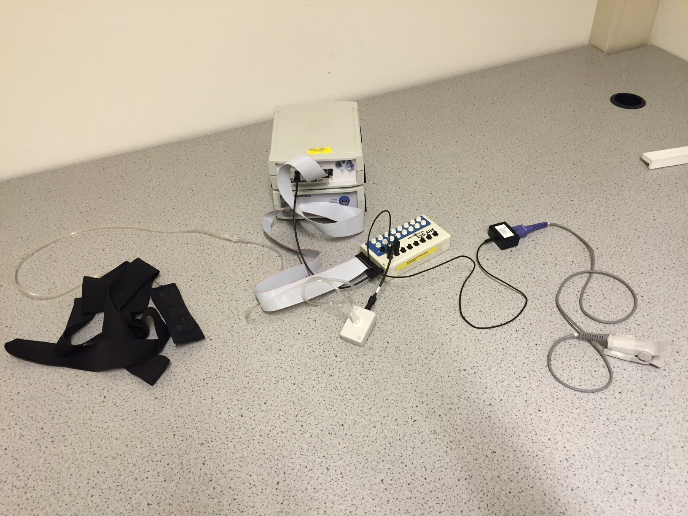leio’ subfolder to load the EEG files.
* The script will convert the data and also detect peaks (heart beats).
* The result is that the EEG file will get two other files with the same name but with ‘_hera.mat’ and ‘_hera.puls’ extensions.

Step 3: Visual inspection / correction in HeRa

* Put the ‘hera’ folder in your matlab path and run it (type ‘hera’).
* Click ‘Open’ and locate your ‘… _hera.puls’ file.
* In the upper figure, you will see the pulse recording (black), the interbeat intervals (red) and the scan trigger pulses (in blue, at the bottom).
* Inspect and correct the data for the period of interest. In the example dataset, that is only the first of the three scan sessions (the first series of blue indicators). This runs from approximately 135 to 450 seconds into the recording.
* You can browse the data using the zoom controllers at the top of the GUI.
* There’s a small vertical line above the middle of the top figure. When you click “insert peak”, a new peak is added at that location. When you click “remove peak”, the peak closest to this point is removed. Periods with bad data recordings that cannot be repaired can be rejected by zooming this period and then clicking “reject zoomed”. These data will be interpolated for RETROICOR.
* Click “save” when ready.

Step 4: Creating the RETROICOR regressors

* The RETROICOR variables can be created by running ‘RETROICOR_setup_subject.m’.
* In the dialog box, first point to the ‘.mat’ file created by HeRa. Then enter two time points (in seconds) between which the sequence was run for which RETROICOR regressors should be created. No scan triggers that do not belong to this functional series should occur within this period. For the example dataset, you can enter 135 and 450. Finally, enter the amount of scans that are discarded at the beginning of the recording. In the example dataset, scan 1 to 5 have been dismissed (to allow for T1 equilibration), so enter 5. This function uses ‘RETROICOR_calc.m’ to calculate the RETROICOR regressors. The output is saved to “RETROICOR_regressors.mat’. If you load this into matlab you will get a variable R, which is an array with TRs in rows, and columns for:
  + 1-10: Cardiac phase regressors
  + 11-20: Respiratory phase regressors
  + 21: Heart rate frequency (6 s windowed)
  + 22. Heart rate variability (6 s windowed)
  + 23 Respiration (raw data averaged per TR)
  + 24 Respiratory amplitude (9 s windowed)
  + 25 Respiratory frequency (9 s windowed)
  + 26 RVT: Frequency times amplitude of respiration (average per TR)

Step 5: Testing the RETROICOR regressors

* To see how much variance is explained by these variables, you can put them into an SPM model and fit the regressors onto the EPI data that was acquired simultaneously.
* The EPI data were acquired using a multiband EPI sequence on the DCCN’s Siemens Prisma scanner, with TR / TE 882 / 23.6 ms, FOV: 212 x 212 mm, 106 matrix, 60 slices, 2 mm isotropic voxels (converted to nifti and realigned/resliced only).
* You can specify your own model in your favourite software package, or simply use the one that is in the EPI_data/model folder (‘job_model_setup_estimate.mat’), which is a saved job batch for SPM8. If you load and run this in SPM8, the SPM.mat in the same folder will be overwritten. If you open this SPM.mat in SPM8 - results, you can pick one of the regressor(s) explained above to see how much variance they explain. An F-test across all cardiac phase regressors should now give you the result shown below (note the data are in native space).
* Note that normally you would like to include realignment parameters as well, which can be done by combining the RETROICOR and realignment parameter regressors and entering them together into your model.

